**CSS Layout**

**Overview**

Demonstrate your proficiency with CSS floats along with margins and padding by modifying style.css so that lab3.html looks similar to that shown in Figure 1.

**Instructions**

1. Examine lab3.html in the browser. The HTML does not need to be modified for this project.
2. Change the margins and padding of the <article> element. For most of the margins, paddings, widths, and heights, you should use em units.
3. Use the techniques from Sections 5.3.3 and 5.3.4 to display the content within the <article>. The <footer> uses the same float techniques. It is okay to use pixel units for the overlapping elements.
4. The colors used in this example are: #F5F5F5, #FF8800, and #474747. You are also free to use whatever colors you like.

**Test**

1. Be sure to test in more than one browser and also try increasing/decreasing the browser zoom level. If you have used em units for font sizes and most margin and padding values, it should scale to the different zoom levels.

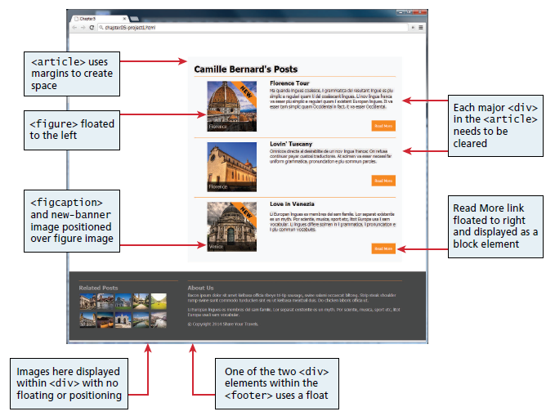

Figure Completed Answer